Q. Create a text editor application . It should perform operation like cut,copy,paste and change in font,color of the selected text. Aslo implements new open and save-file menu option.On editor status bar should should be display the status of caps lock key on first panel and current date on second panel.

Solution:

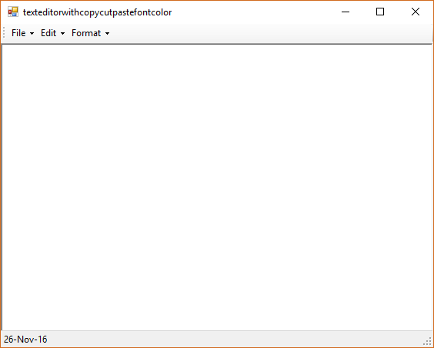

Imports System.IO

Public Class texteditorwithcopycutpastefontcolor

Private Sub SaveToolStripMenuItem_Click(sender As System.Object, e As System.EventArgs) Handles SaveToolStripMenuItem.Click

Dim sfd As New SaveFileDialog

Dim filename As String

sfd.ShowDialog()

filename = sfd.FileName

Dim fout As New StreamWriter(filename)

fout.WriteLine(RichTextBox1.Text)

fout.Close()

End Sub

Private Sub OpenToolStripMenuItem_Click(sender As System.Object, e As System.EventArgs) Handles OpenToolStripMenuItem.Click

Dim ofd As New OpenFileDialog

Dim filename As String

ofd.ShowDialog()

filename = ofd.FileName

Dim fin As New StreamReader(filename)

RichTextBox1.Text = fin.ReadToEnd()

fin.Close()

End Sub

Private Sub NewToolStripMenuItem_Click(sender As System.Object, e As System.EventArgs) Handles NewToolStripMenuItem.Click

RichTextBox1.Text = ""

End Sub

Private Sub CopyToolStripMenuItem_Click(sender As System.Object, e As System.EventArgs) Handles CopyToolStripMenuItem.Click

RichTextBox1.Copy()

End Sub

Private Sub PasteToolStripMenuItem_Click(sender As System.Object, e As System.EventArgs) Handles PasteToolStripMenuItem.Click

RichTextBox1.Paste()

End Sub

Private Sub CutToolStripMenuItem_Click(sender As System.Object, e As System.EventArgs) Handles CutToolStripMenuItem.Click

RichTextBox1.Cut()

End Sub

Private Sub ColorToolStripMenuItem_Click(sender As System.Object, e As System.EventArgs) Handles ColorToolStripMenuItem.Click

Dim cdb As New ColorDialog

cdb.ShowDialog()

RichTextBox1.BackColor = cdb.Color

End Sub

Private Sub FontToolStripMenuItem_Click(sender As System.Object, e As System.EventArgs) Handles FontToolStripMenuItem.Click

Dim fdb As New FontDialog

fdb.ShowDialog()

RichTextBox1.Font = fdb.Font

End Sub

Private Sub texteditorwithcopycutpastefontcolor_Load(sender As System.Object, e As System.EventArgs) Handles MyBase.Load

ToolStripStatusLabel2.Text = Now.Date

End Sub

Private Sub RichTextBox1_KeyUp(sender As Object, e As System.Windows.Forms.KeyEventArgs) Handles RichTextBox1.KeyUp

If Control.IsKeyLocked(Keys.CapsLock) Then

ToolStripStatusLabel1.Text = "CAPS"

Else

ToolStripStatusLabel1.Text = ""

End If

End Sub

End Class

